 | 12.1.7 Editors - Geometry Nodes Editor - Header - Add Menu - Input - Gizmo
Table of content
Detailed table of content 1
Add menu - Input - Gizmo 2
Dial Gizmo 2
Linear Gizmo 3
Transform Gizmo 4

Detailed table of content
Detailed table of content
Detailed table of content 1
Add menu - Input - Gizmo 2
Dial Gizmo 2
Inputs 2
Value 2
Position 2
Up 2
Screen Space 2
Radius 3
Properties 3
Color 3
Pin Gizmo 3
Outputs 3
Transform 3
Linear Gizmo 3
Inputs 3
Value 3
Position 3
Direction 3
Screen Space 3
Radius 4
Properties 4
Color 4
Draw Style 4
Pin Gizmo 4
Outputs 4
Transform 4
Transform Gizmo 4
Inputs 4
Value 4
Position 4
Rotation 4
Screen Space 5
Radius 5
Properties 5
Pin Gizmo 5
Outputs 5
Transform 5

Add menu - Input - Gizmo
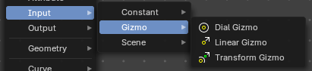
Here you find input nodes.

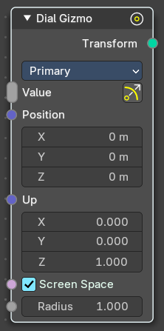
Dial Gizmo
Displays the rotation gizmo in the 3d view.

Inputs

Value
Show or hide the widget.

Position
Where to show the widget in relation to the object.

Up
The up vector to define the rotation.

Screen Space
Use screen space or object space values to display the widget.

Radius
The radius of the widget.

Properties

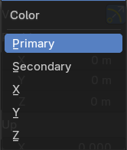
Color
The widget color, defined in the theming.

Pin Gizmo
Always display the gizmo.

Outputs

Transform
The output transform. No positions, no matrices, Gizmos.

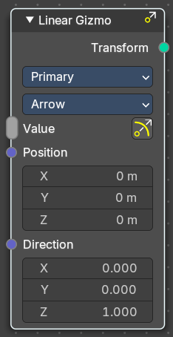
Linear Gizmo
Displays the translation gizmo in the 3d view.

Inputs

Value
Show or hide the widget.

Position
Where to show the widget in relation to the object.

Direction
The direction vector.

Screen Space
Use screen space or object space values to display the widget.

Radius
The radius of the widget.

Properties

Color
The widget color, defined in the theming.

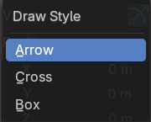
Draw Style
How to draw the widget.

Pin Gizmo
Always display the gizmo.

Outputs

Transform
The output transform. No positions, no matrices, Gizmos.

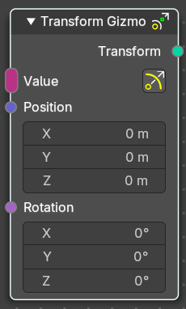
Transform Gizmo
Displays the transform gizmo in the 3d view.

Inputs

Value
Show or hide the widget.

Position
Where to show the widget in relation to the object.

Rotation
The rotation vector.

Screen Space
Use screen space or object space values to display the widget.

Radius
The radius of the widget.

Properties

Pin Gizmo
Always display the gizmo.

Outputs

Transform
The output transform. No positions, no matrices, Gizmos.

